Task 1. Express.js with Pug Template Engine
a) Set up an Express.js web application with Pug template engine.
b) Implement dynamic content rendering using Pug
c) Database integration using SQLite in Express.js

Please refer to the code in the folder ‘Task 1-4’.
The screenshots below show,
- The express.js setup done and the port is set to 3000.
- The Pug is set as the view Engine.
- The SQLite is set as database. The database name is ‘students’. It contains a table ‘students’
- ‘viewAllStudents’ selects all the records from ‘students’ table in ‘students’ database and the records are passed to ‘viewAllStudents.pug’ view to display the list.

App.js file:
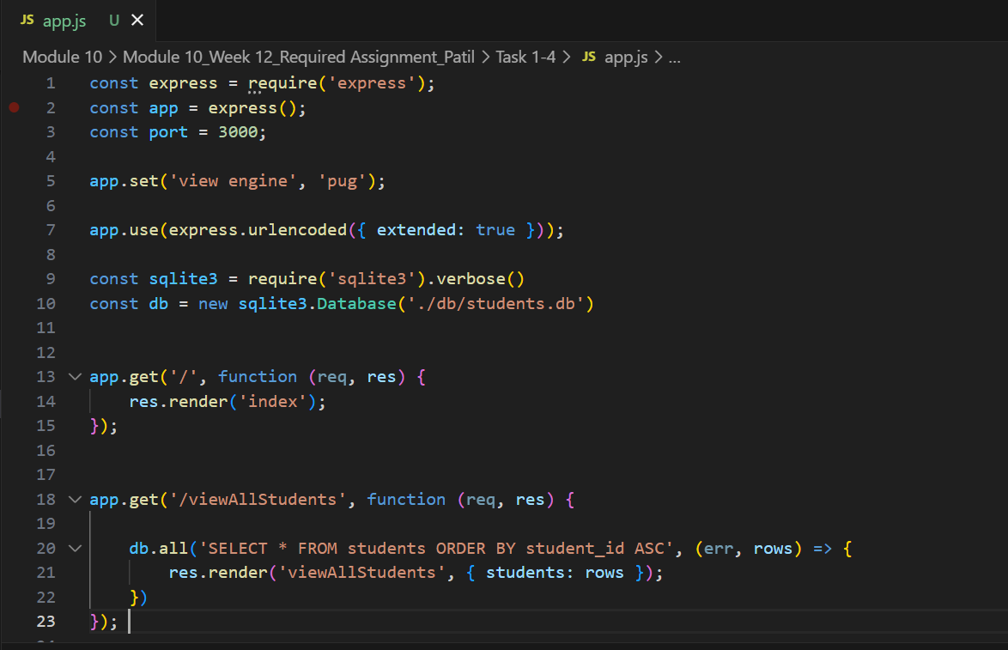
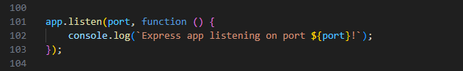

viewAllStudents.pug:
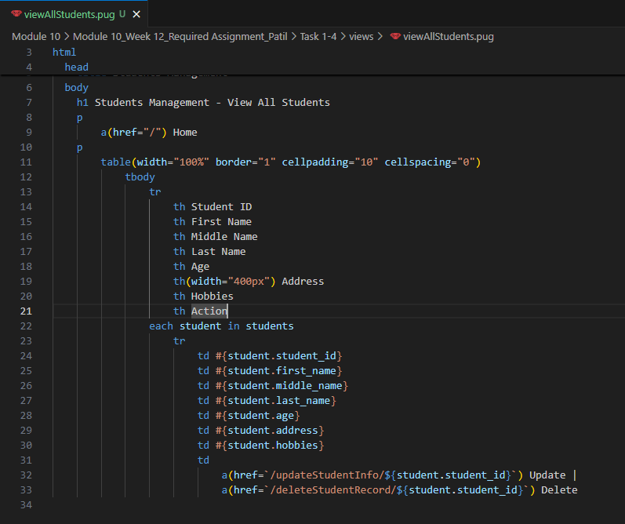

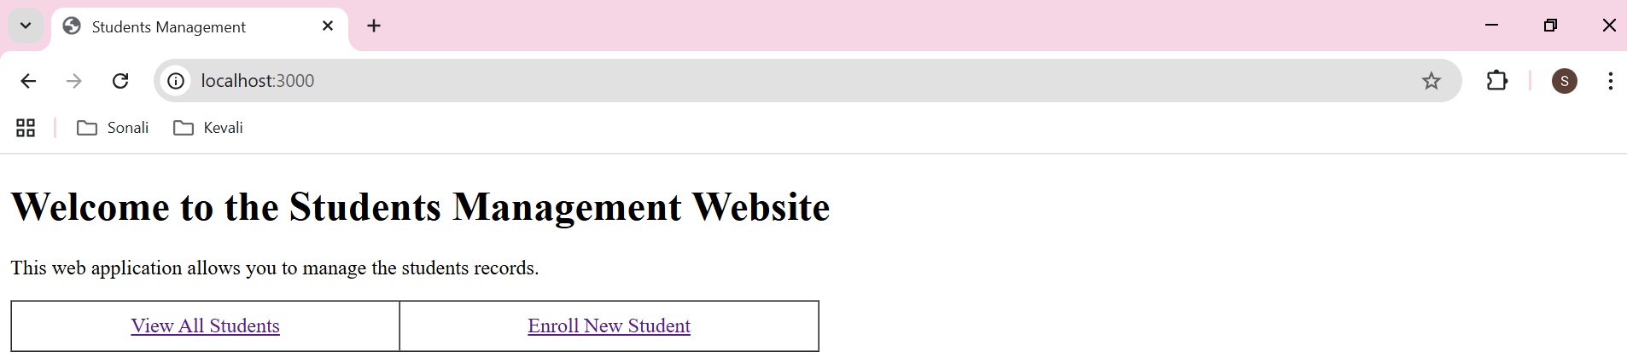

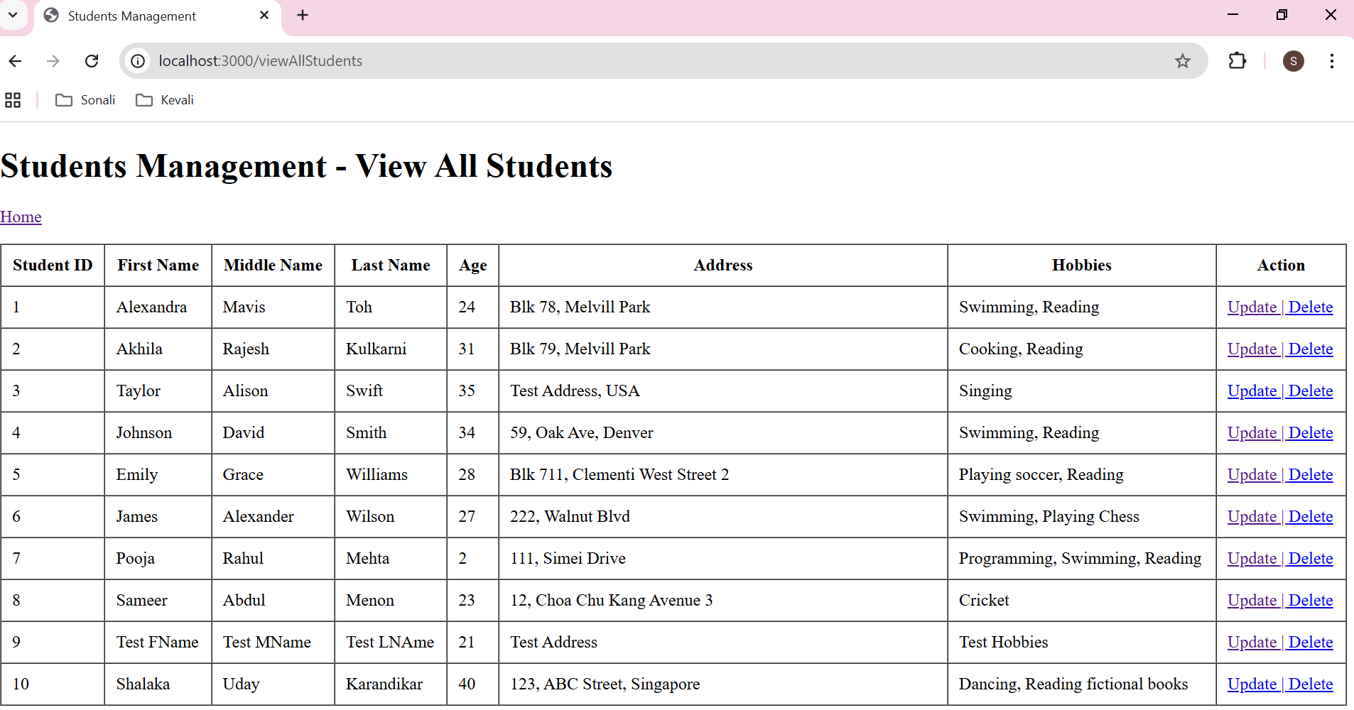

Task 2. Flask with Jinja2 Template Engine
a) Set up a Flask web application with Jinja2
b) Dynamic content rendering with Jinja2
c) Handle different HTTP methods in Flask

Please refer to the code in the folder ‘Task 2-4’. The screenshots below show,
- The Flask setup is done and the required import like render_template etc is done.
- The HTTP methods like ‘GET’ is used for retrieving the data, ‘POST” is used for update and delete records.
- The SQLite is set as database. The database name is ‘students’. It contains a table ‘students’
- Endpoint ‘/viewAllStudents’ selects all the records from ‘students’ table in ‘students’ database and the records are passed to ‘viewAllStudents.html’ template to display the list.

App.py:
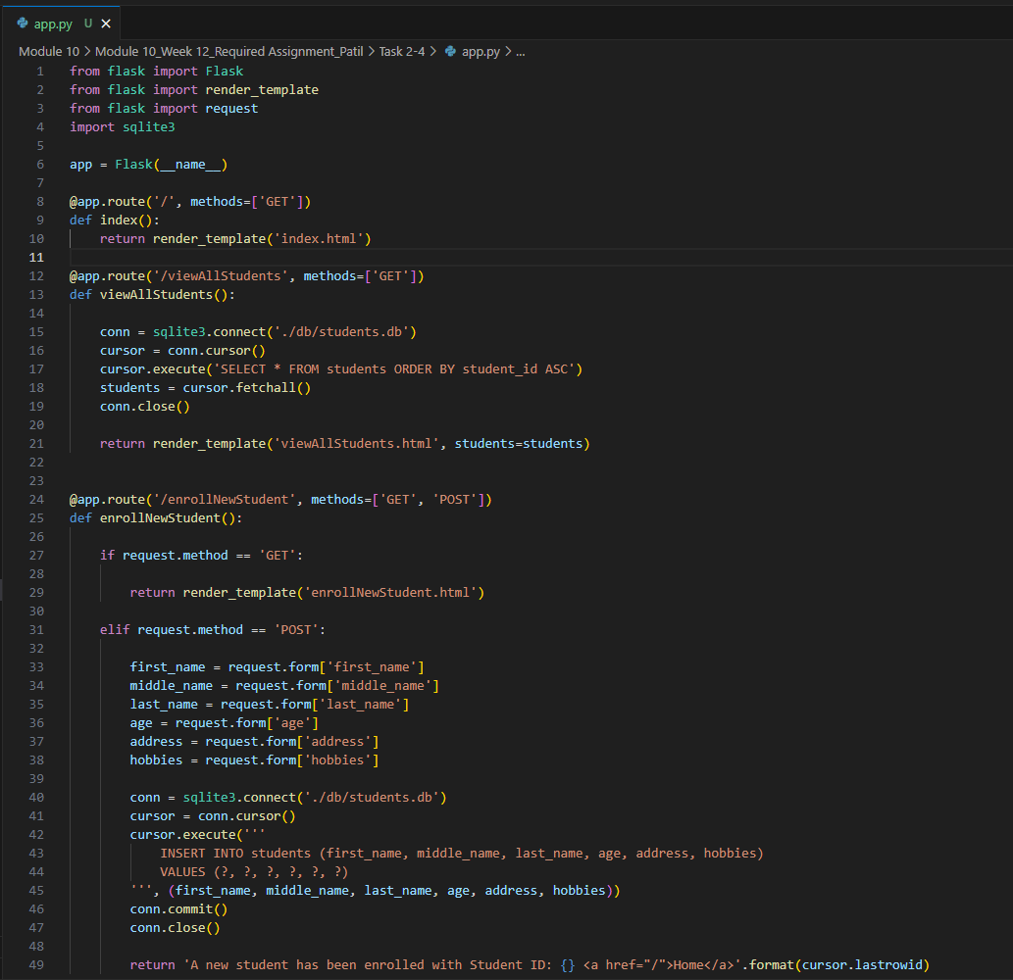

viewAllStudents.html:
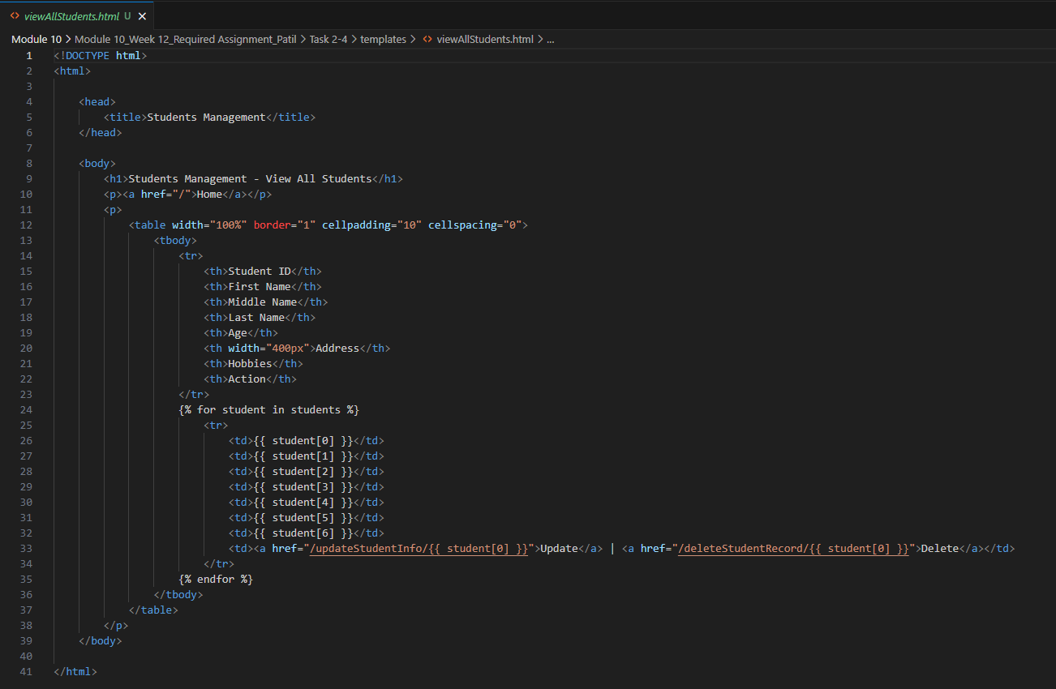

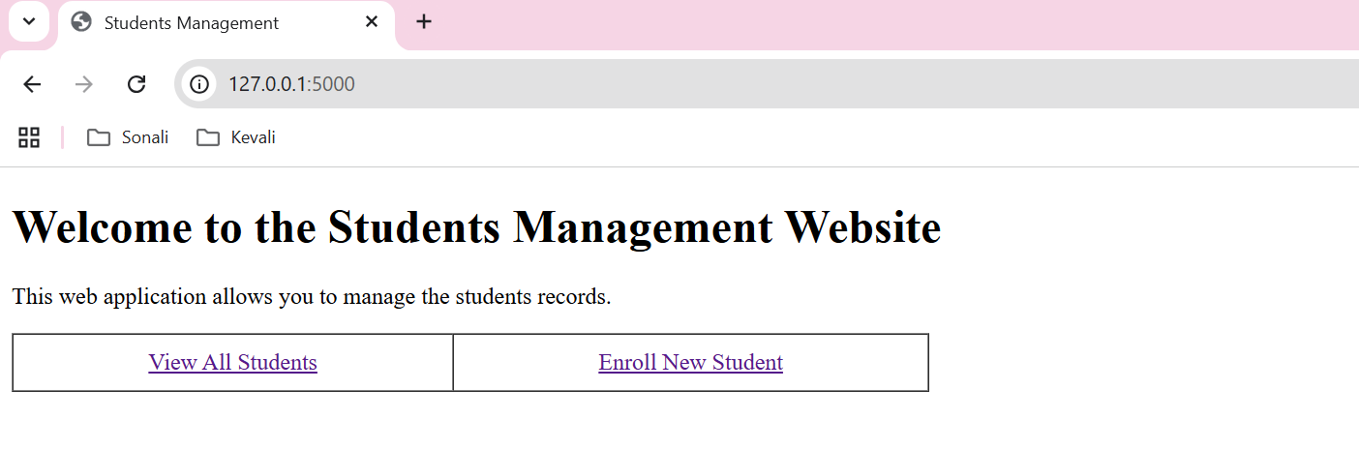

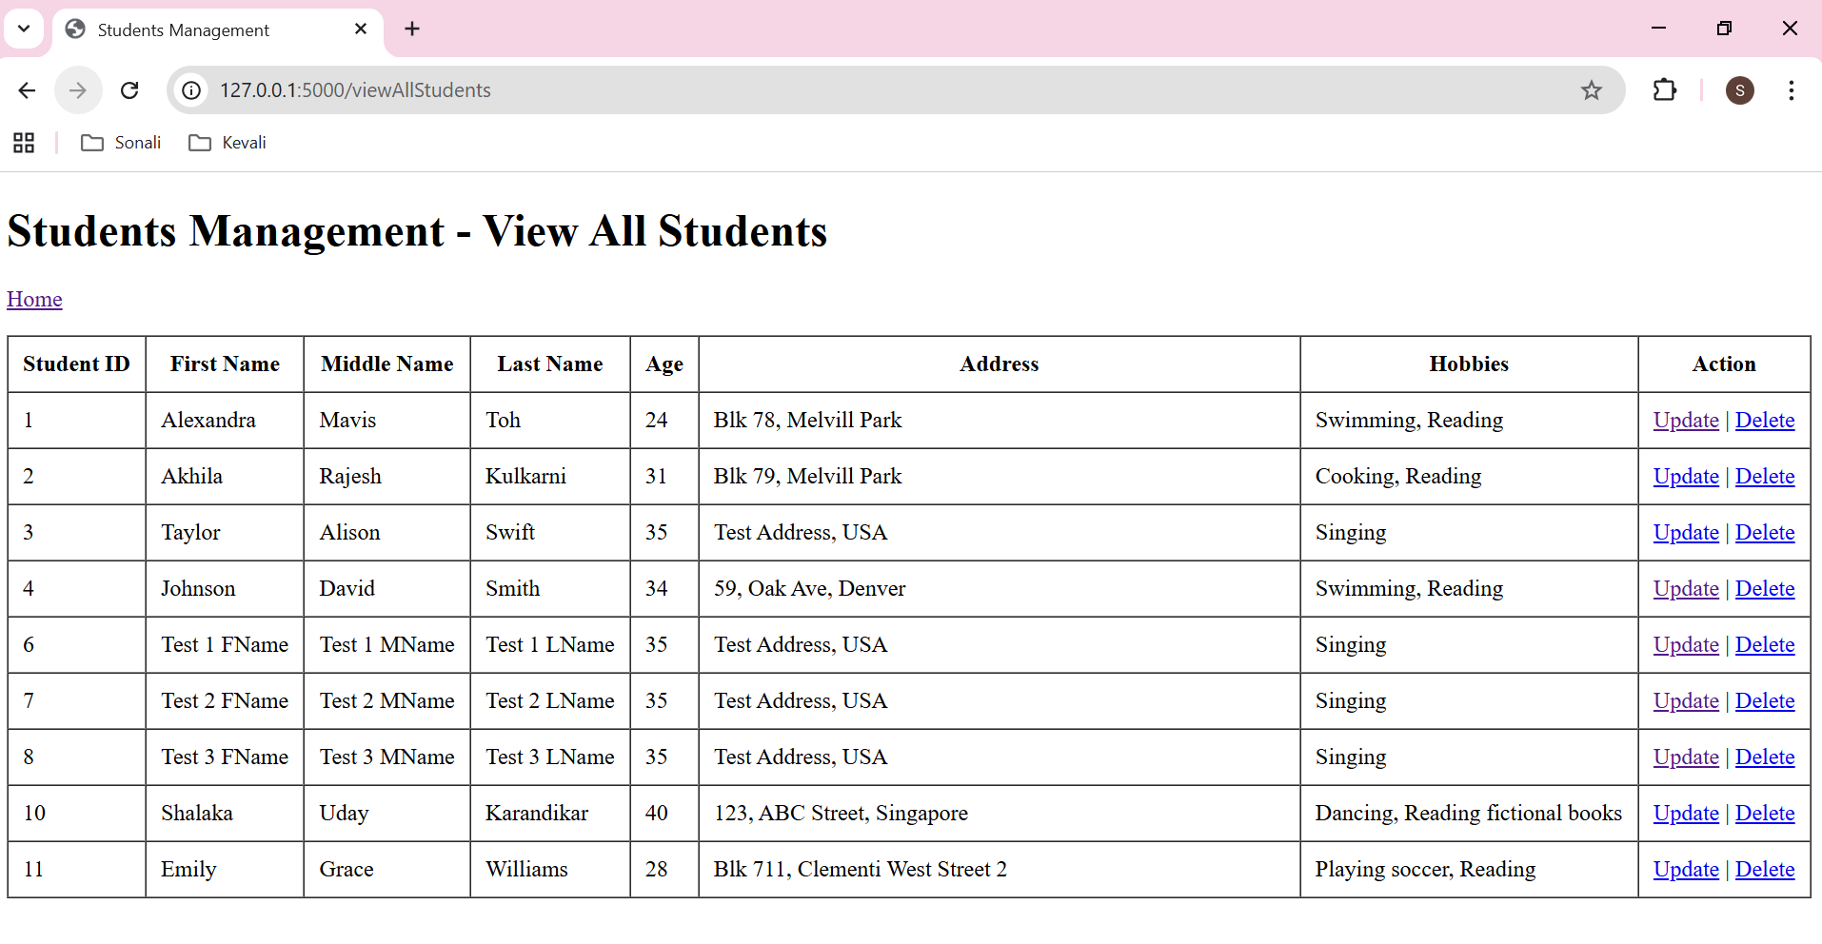

Task 3. Static Assets and Session Management
- Serve static assets in Express.js
Please refer to the code in folder ‘Task 3 - Express’.
- Below line means any request to /images will retrieve the files from images/ folder located at the root.
app.use('/images', express.static(process.cwd() + '/images'));
- The images can be used in ‘index.pug’ view as below.
img(src='./images/Image1.jpg', style='width: 600px;')
- Screenshot for code for ‘app.js’ is on the next page.
- Screenshot for code for ‘index.pug’ is on the next page.

b) Manage session state using Express.js sessions
Please refer to the code in folder ‘Task 3 - Express’.
In app.js,
- The express.js setup done and the port is set to 3000. ‘express-session’ is used for session management.
- ‘express-session’ is configured with a secret and standard options.
- Route ‘/set-session’ sets a session variable username to 'Alice'.
- Route ‘/’, checks req.session.username value, defaults to 'Alice' if not set and passes it to the index.pug template.
In ‘Index.pug’
- ‘Index.pug’ view checks if ‘username’ has value. If yes, it displays it in the greeting ( Hi Alice!). Else it just displays greeting without username.

Code for ‘app.js’ as below.
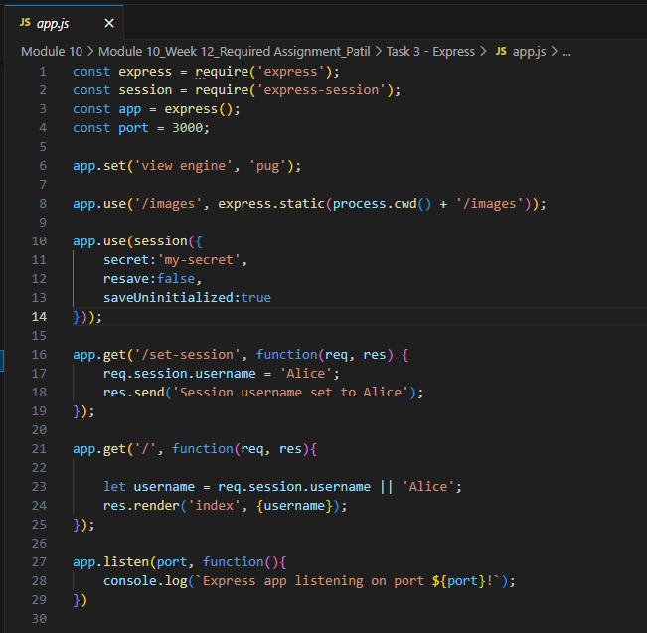

Code for ‘index.pug’ as below.
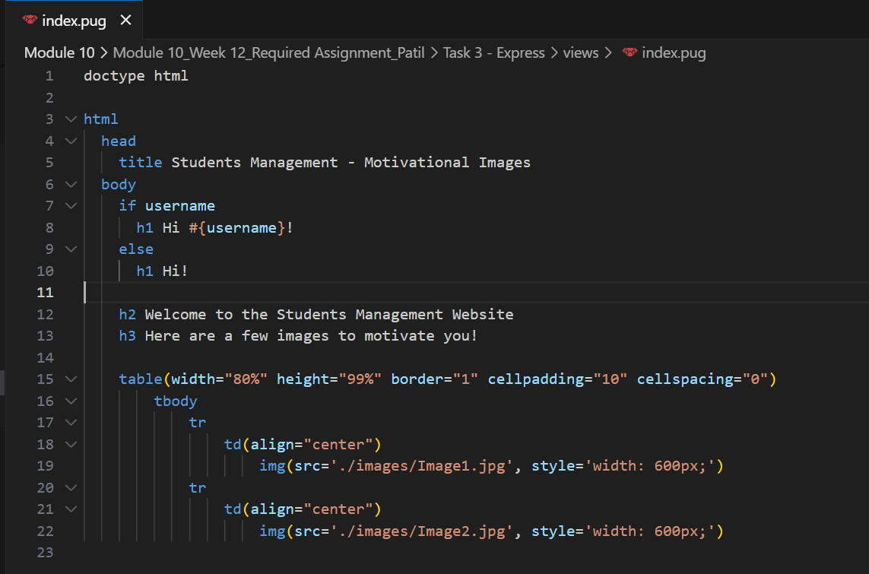

The webpage displayed below:
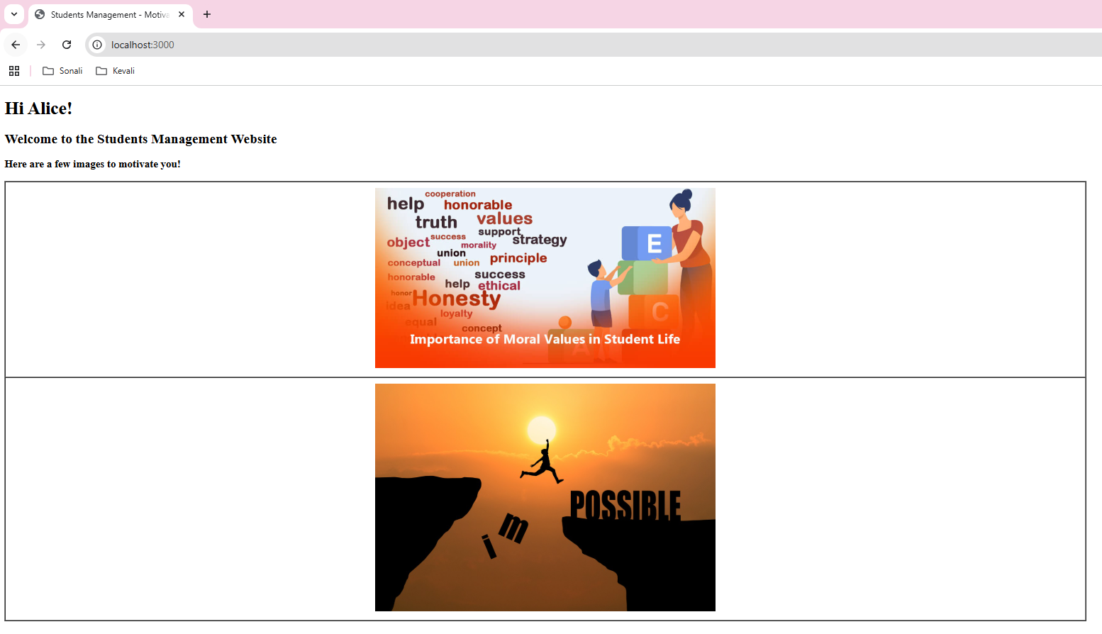

- Serve static assets in Flask
Please refer to the code in folder ‘Task 3 - Flask.

- The images are stored in the ‘static’ folder located at the root folder.
- We can use those static images in the html templates as below.
<img src="../static/Image1.jpg" width="600px" />

- Similarly, we can use other static assets like stylesheet etc.
- Please find below the screenshot of ‘index.html’.

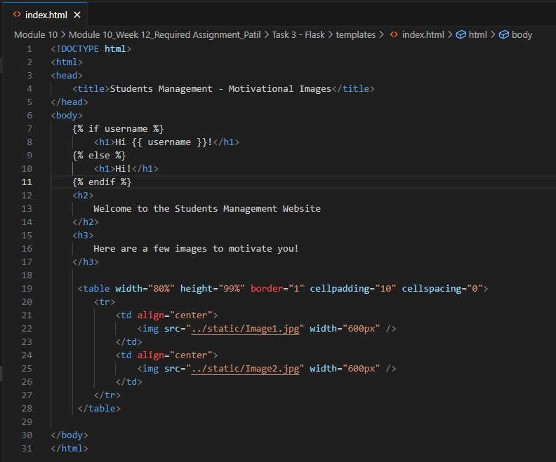

- Manage session state using Flask sessions
Please refer to the code in folder ‘Task 3 - Flask.
- The ‘session’ is imported from ‘flask’.
- Route ‘/set-session’ sets a session variable username to 'Alice'.
- Route ‘/’, checks req.session.username value, defaults to 'Alice' if not set and passes it to the index.html template.
In ‘Index.html
- ‘Index.html template checks if ‘username’ has value. If yes, it displays it in the greeting ( Hi Alice!). Else it just displays greeting without username.
Screenshot for code in app.py:
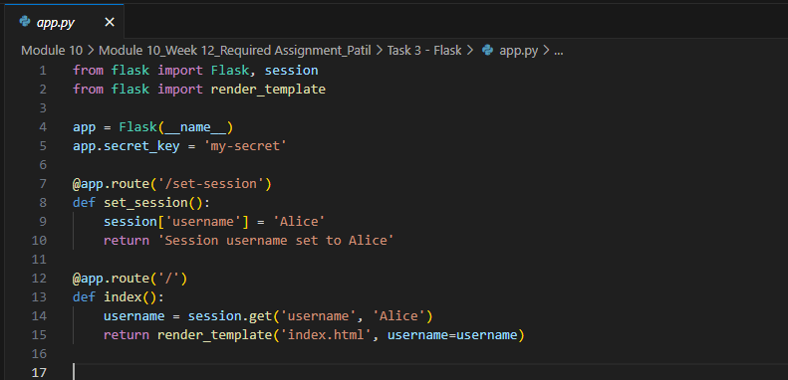

Screenshot for code in index.html:


The webpage displays below:
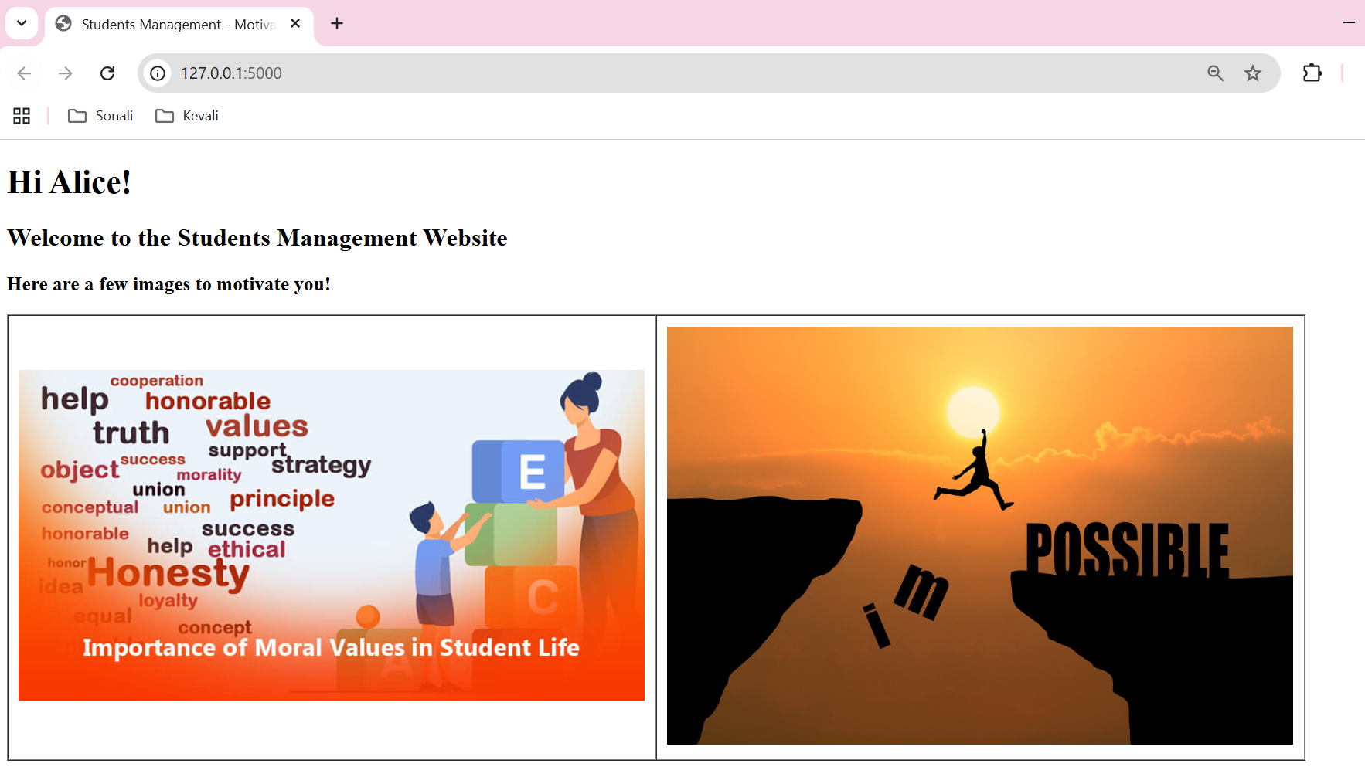

Task 4. Database interaction and CRUD operations
a) Set up a Flask application to perform CRUD operations with SQLite.
Please refer to the code in folder ‘Task 2 – 4’.
- Flask is setup and render_template, request are imported.
- Sqlite3 is setup as database.
- A GET endpoint is set to the root path ‘/’. It renders Jinja2 template ‘index.html’.
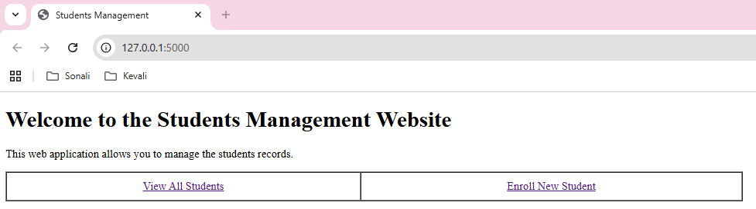

Code from app.py:
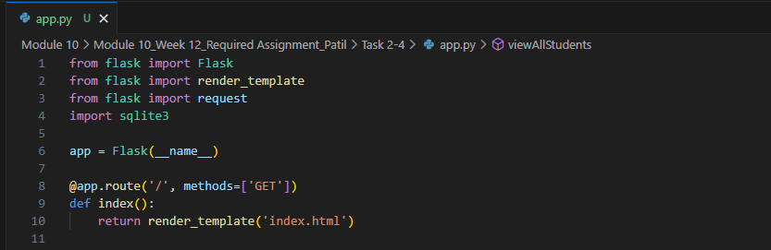

Code from index.html:
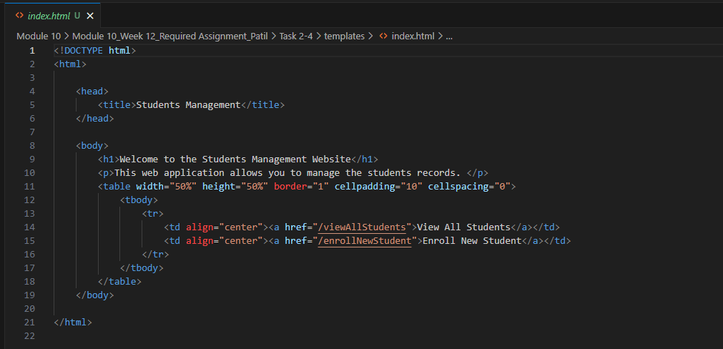

- A GET endpoint '/viewAllStudents' connects to sqlite database ‘students’ and fetches all the rows from ‘students’ table order by student_id. Jinja2 template ‘viewAllStudents.html’ renders the list of all the retrieved students’ records.
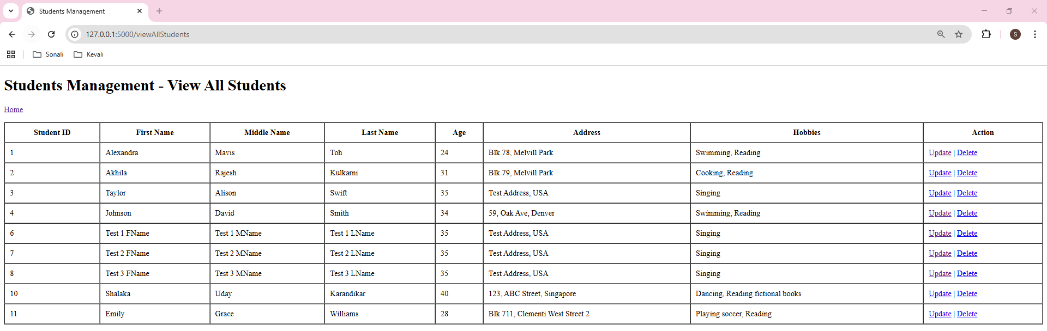

Code from app.py:
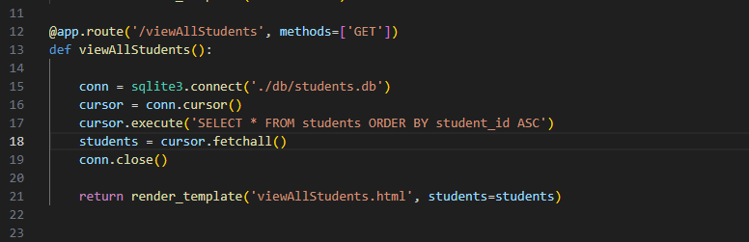

Code from viewAllStudents.html:
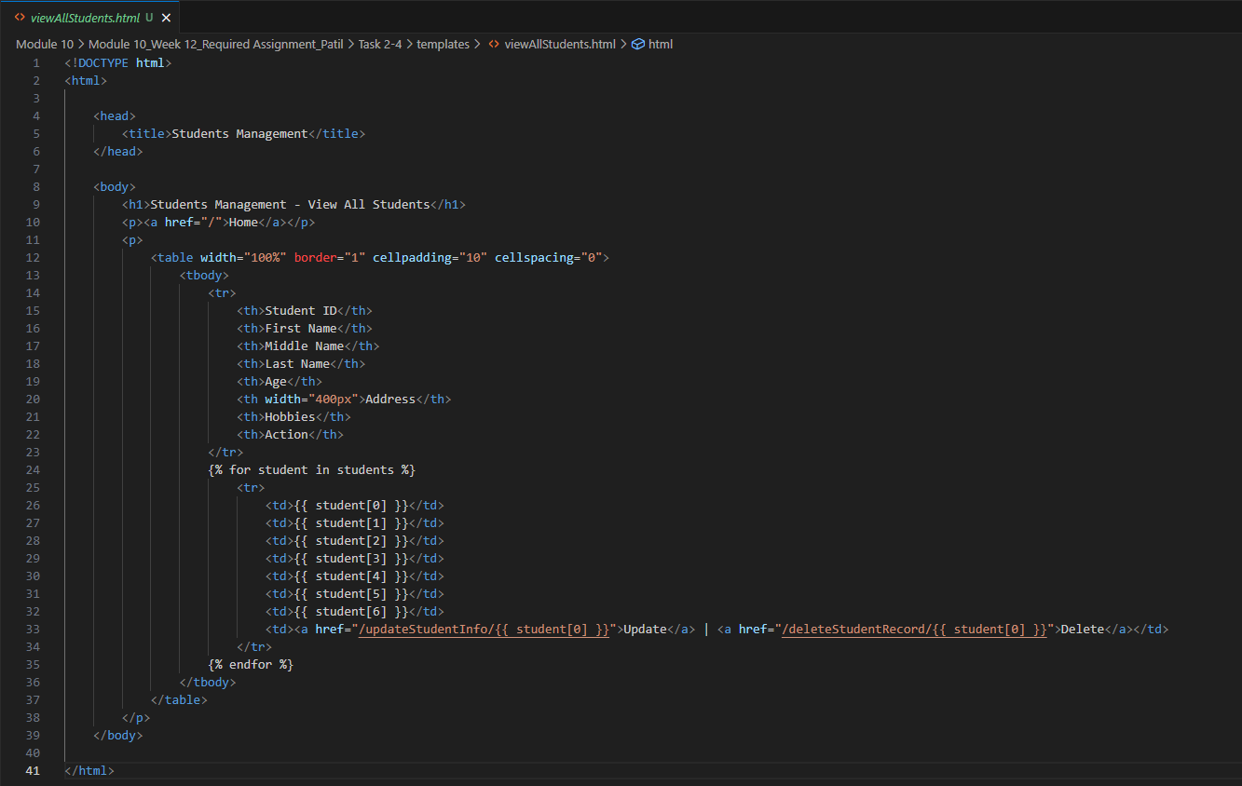

- A GET endpoint ‘/enrollNewStudent’ renders Jinja2 template ‘enrollNewStudent.html’. It displays an empty form for enrolling the student.
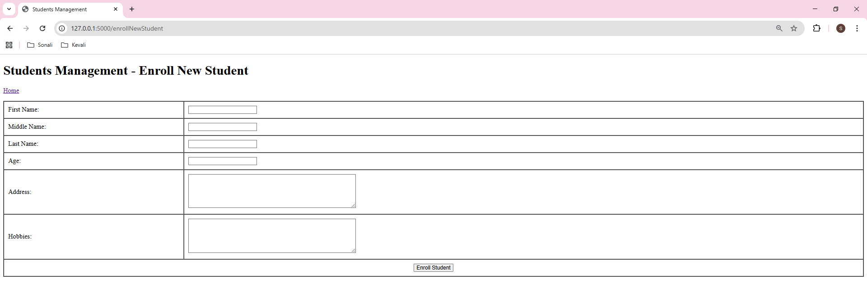

- A POST endpoint ‘/enrollNewStudent’ retrieves the data entered by the user in ‘enrollNewStudent.html’ template and inserts a new student record in students database table. It provides a link for user to redirect to Home page.
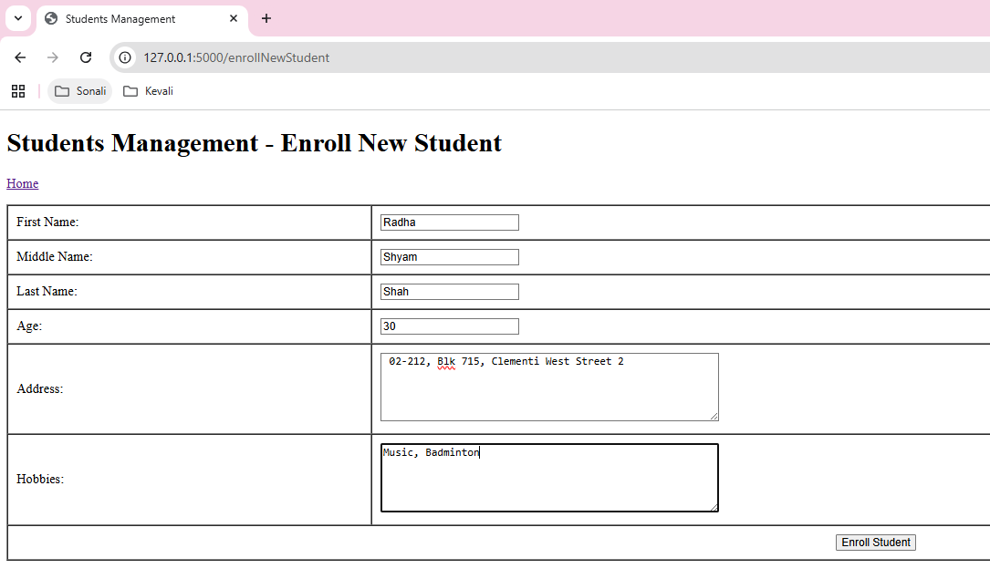

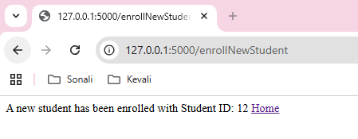

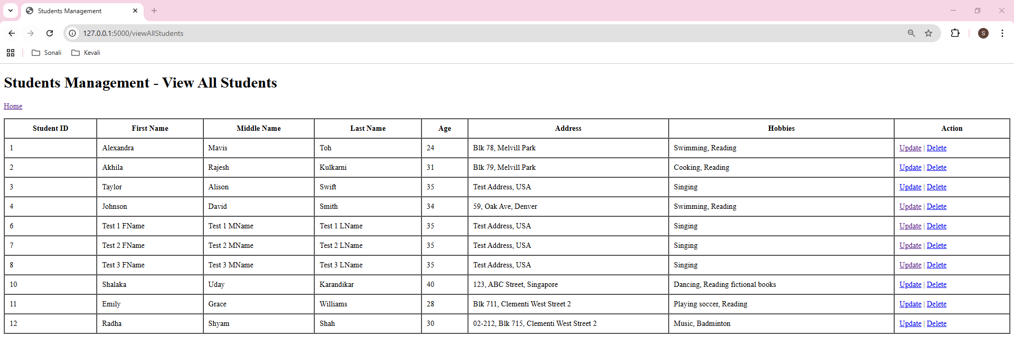

Code from app.py:
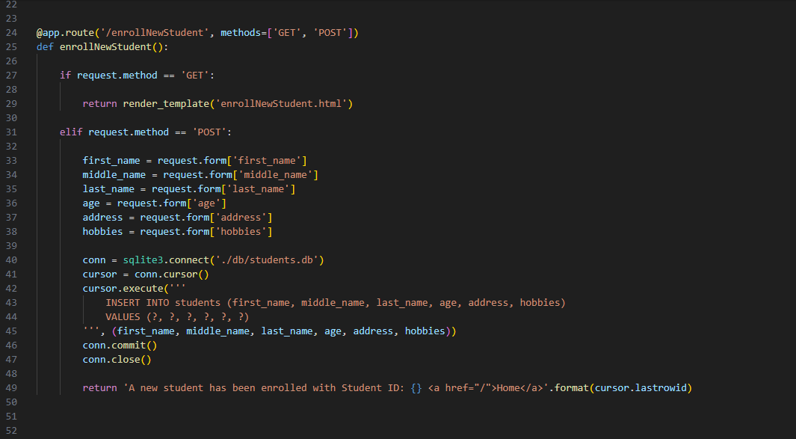

Code from enrollNewStudent.html:
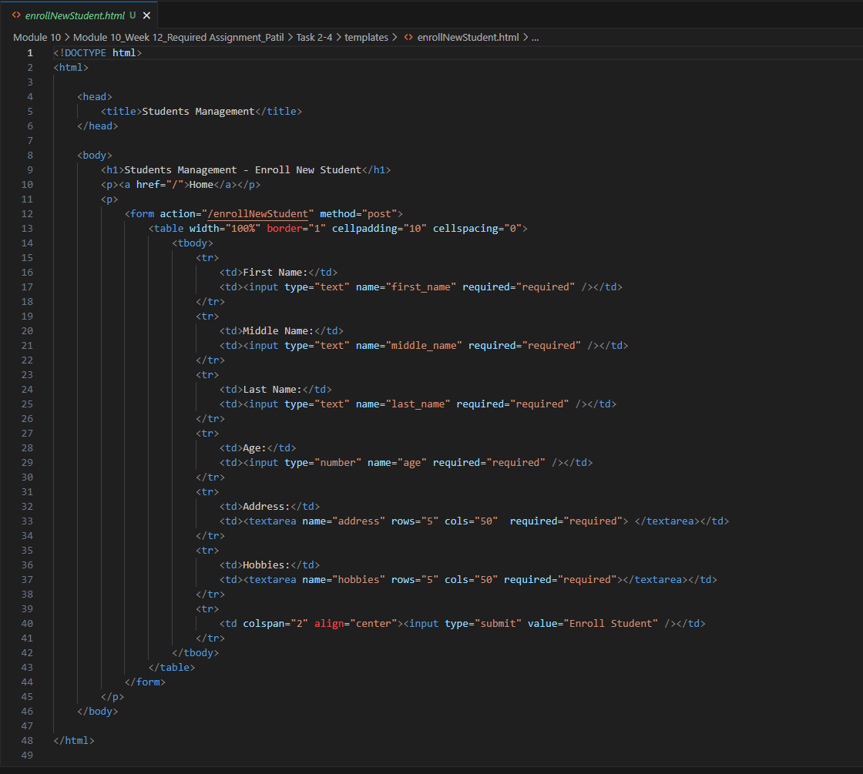

- A GET endpoint ‘/updateStudentInfo’ accepts ‘student_id’ as parameter and retrieves the record for that particular student from the sqlite database. It then displays that record in Jinja2 template, ‘enrollNewStudent.html’. User can edit the existing record data here.
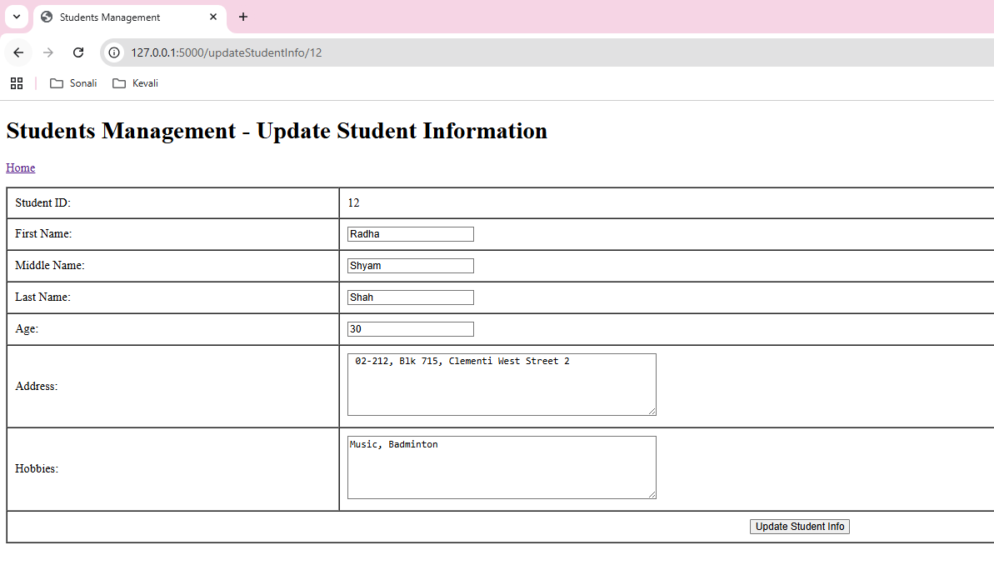

- A POST endpoint ‘/updateStudentInfo’ accepts ‘student_id’ as parameter, retrieves the data edited by user for that particular student id from Jinja2 template, ‘enrollNewStudent.html’. It then updates the student record in sqlite students database. Then it provides a link for user to redirect to Home page.

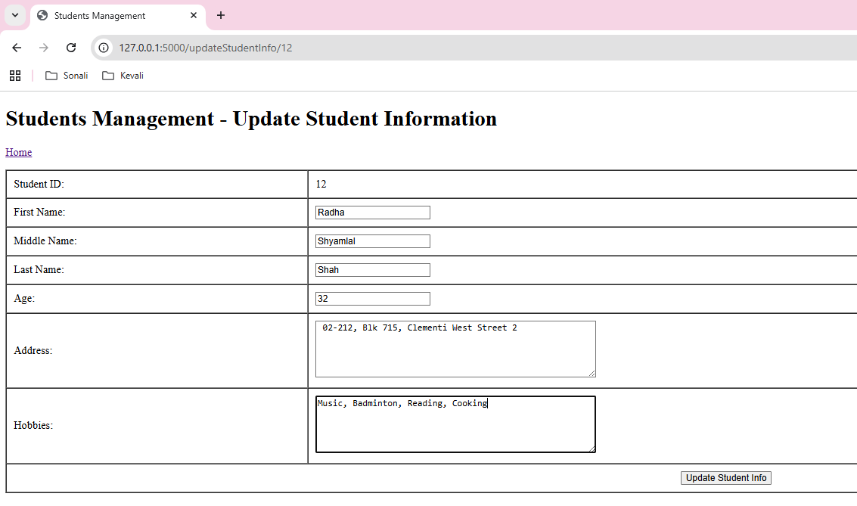

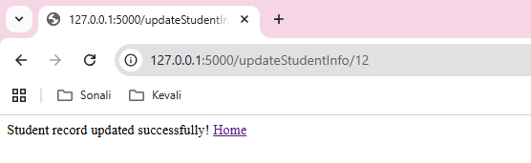
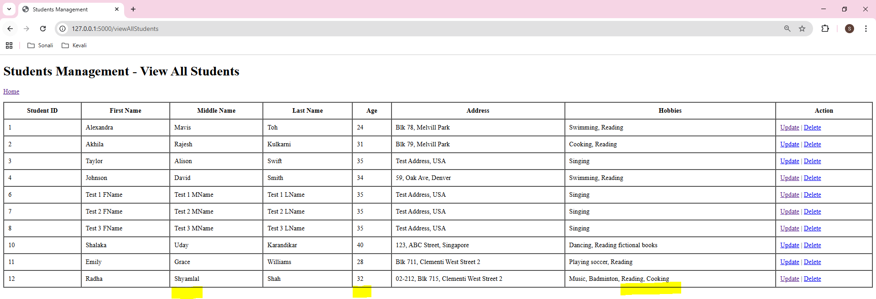

Code from app.py:
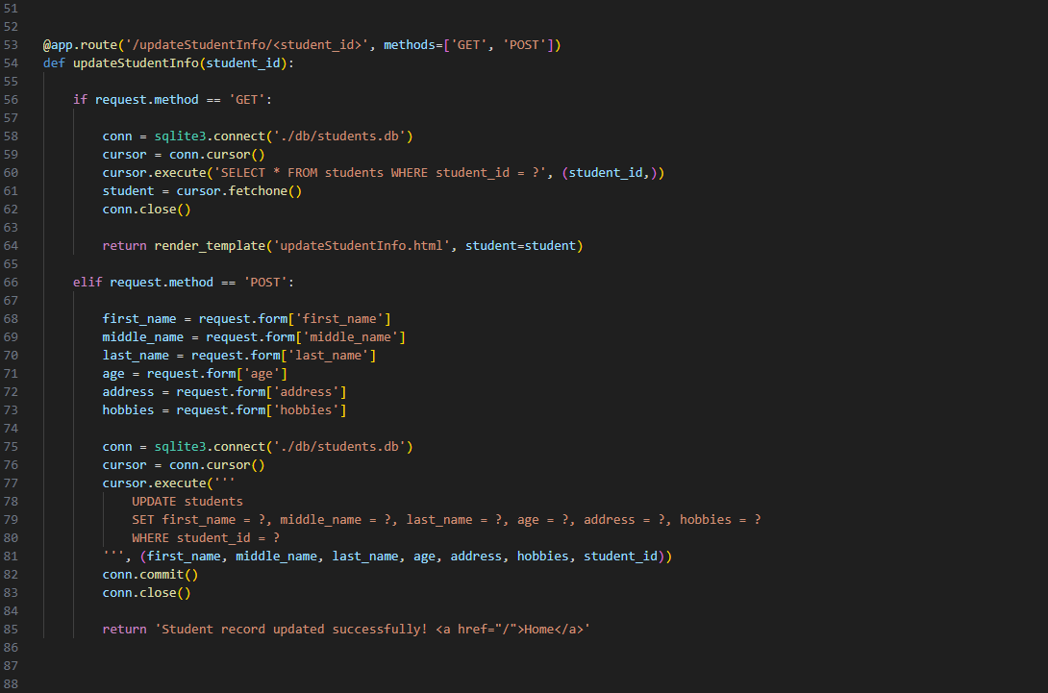

Code from updateStudentInfo.html:
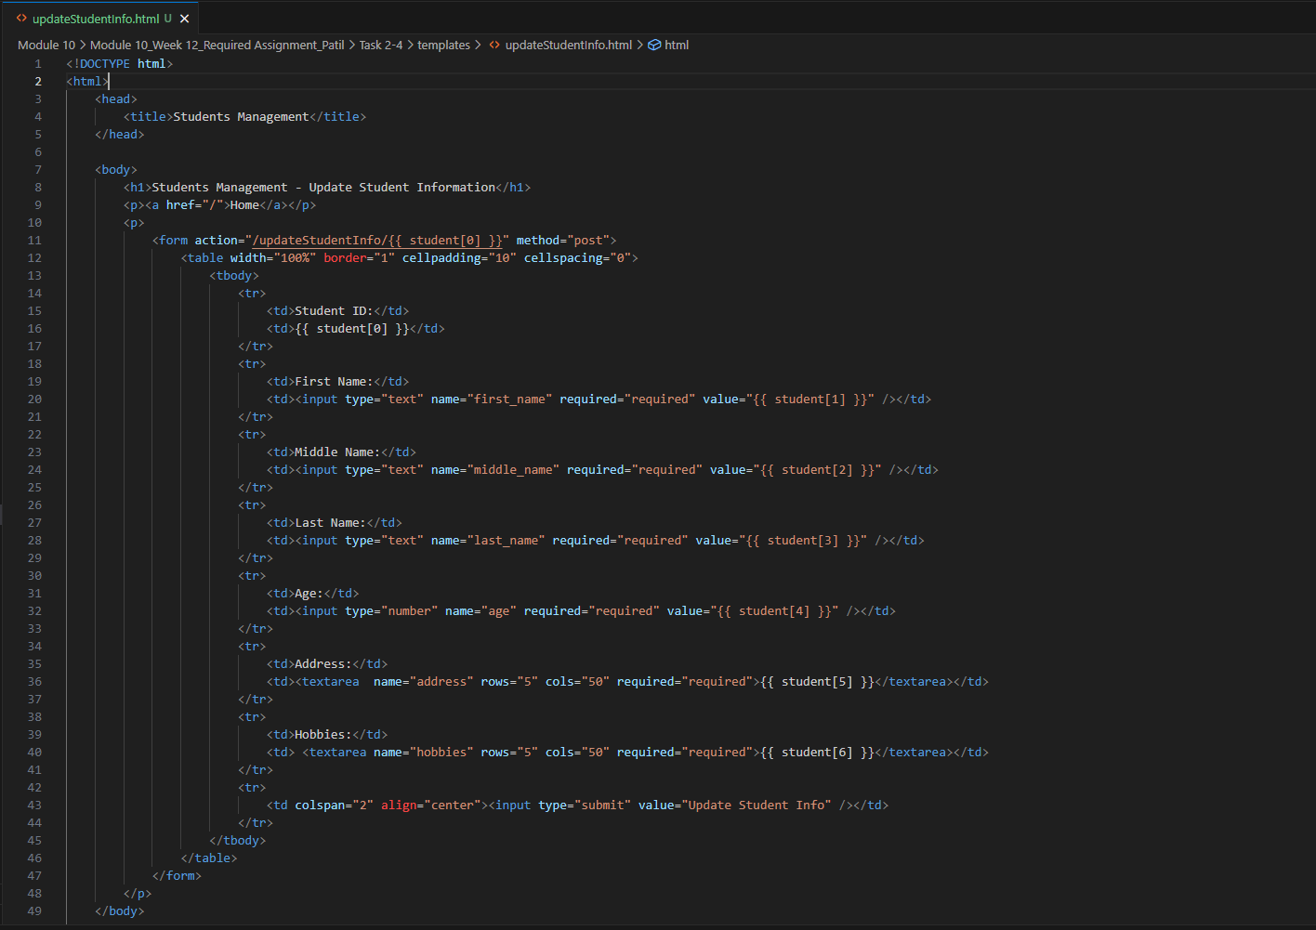

- A GET endpoint ‘/deleteStudentRecord’ accepts ‘student_id’ as parameter, it then retrieves the record for that particular student from ‘students’ database table and displays it using ‘deleteStudentRecord.html’ Jinja2 template.

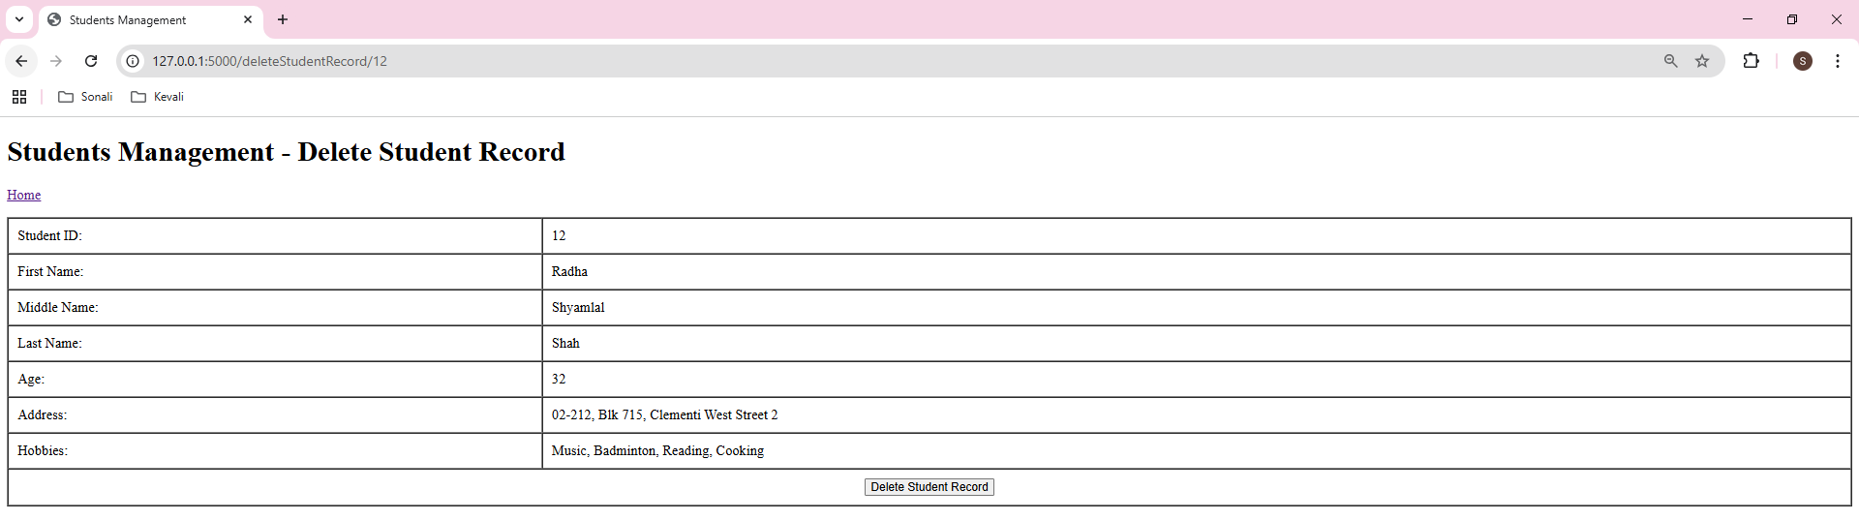

- A POST endpoint ‘/deleteStudentRecord’ accepts ‘student_id’ as parameter, it then Deletes the record for that student by its id. Then it provides a link for user to redirect to Home page.
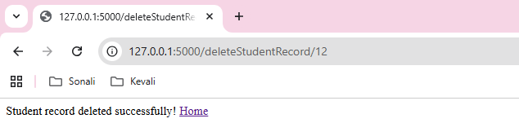

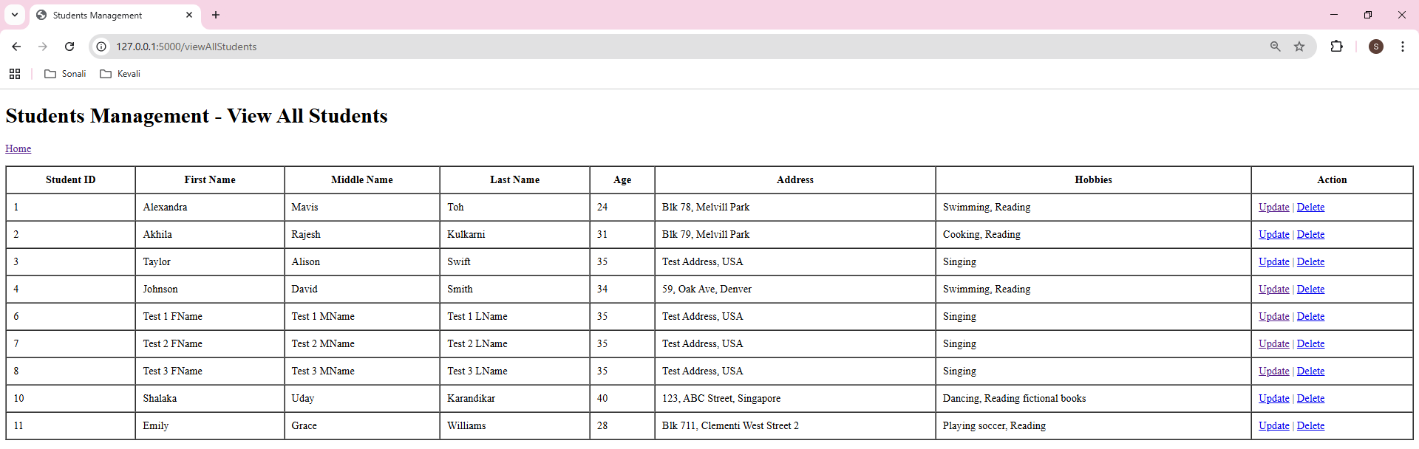

Code from app.py:
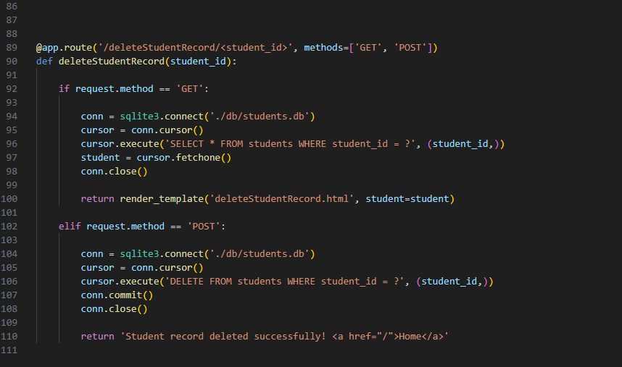

Code from deleteStudentRecord.html:
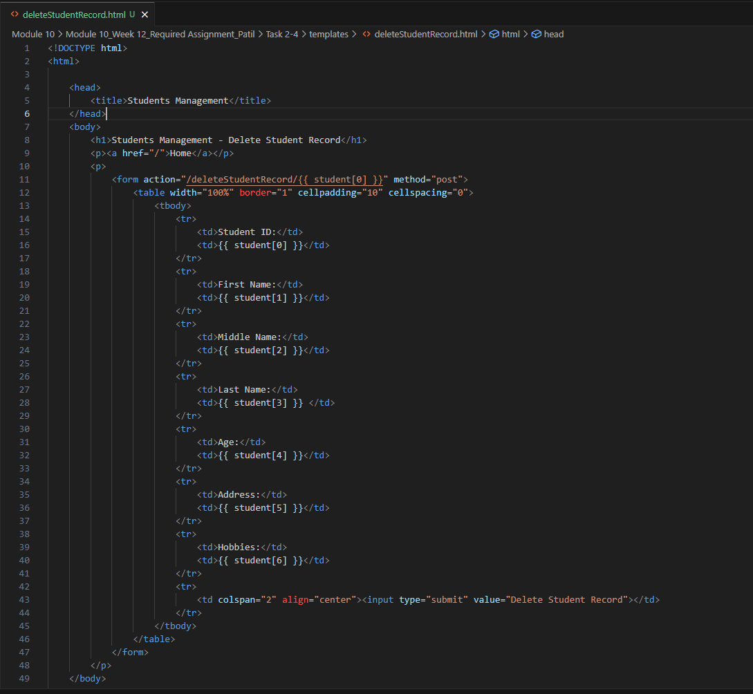

- Set up CRUD operations in Express.js using SQLite.
Please refer to the code in folder ‘Task 1 – 4’.
- Express.js is setup and port is set to 3000.
- The view engine is set as ‘pug’.
- Sqlite3 is setup as database.
- A GET endpoint is set to the root path ‘/’. It renders pug view ‘index.pug.

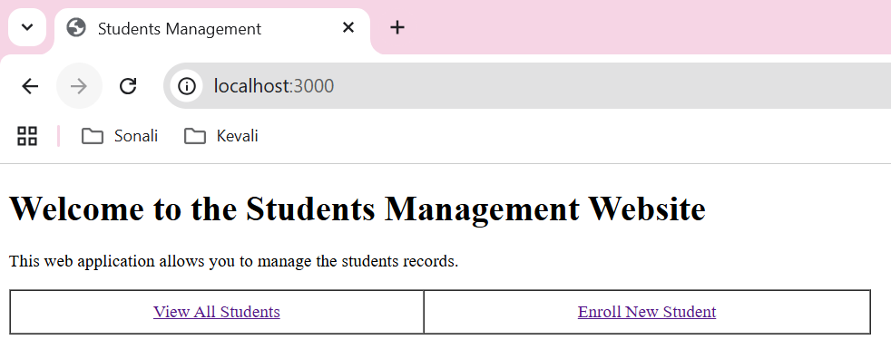
Code from app.js:
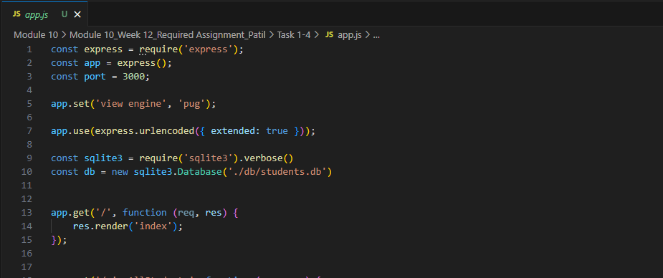



Code from index.pug:
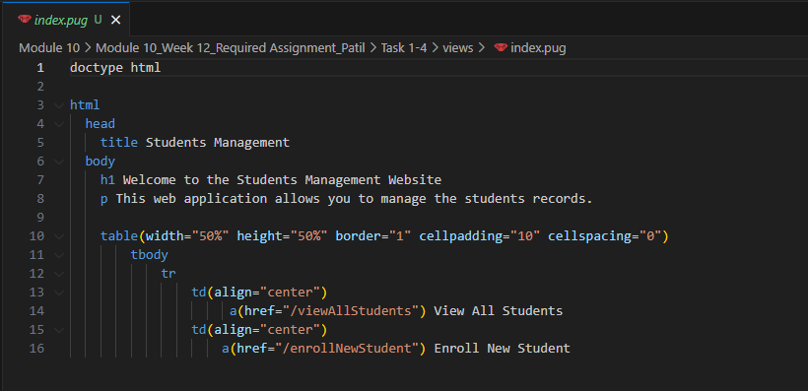

- A GET endpoint '/viewAllStudents' connects to sqlite database ‘students’ and fetches all the rows from ‘students’ table order by student_id. A pug view ‘viewAllStudents.pug’ renders the list of all the retrieved students’ records.

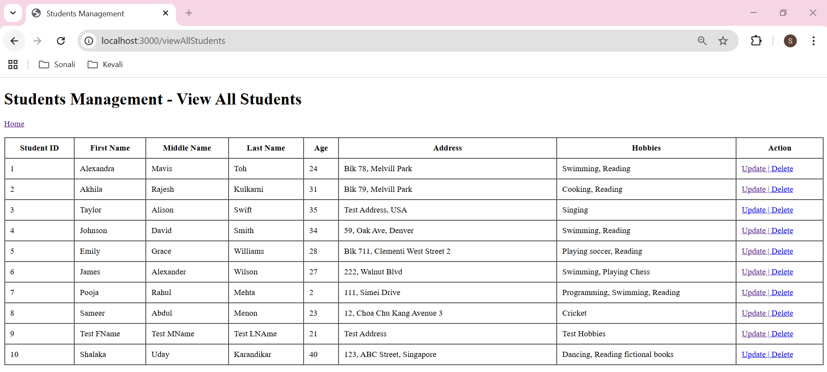

Code from app.js:
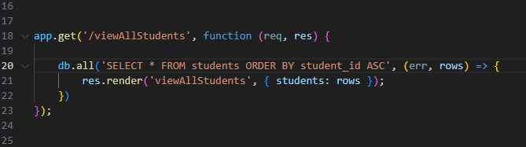

Code from viewAllStudents.pug:
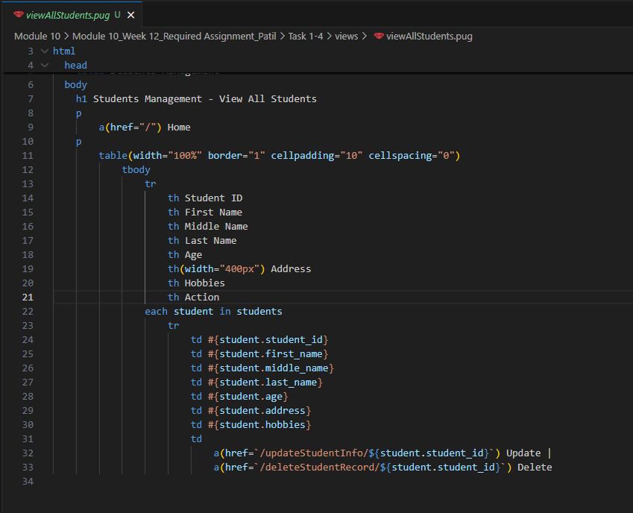

- A GET endpoint ‘/enrollNewStudent’ renders pug view ‘enrollNewStudent.pug’. It displays an empty form for enrolling the student.
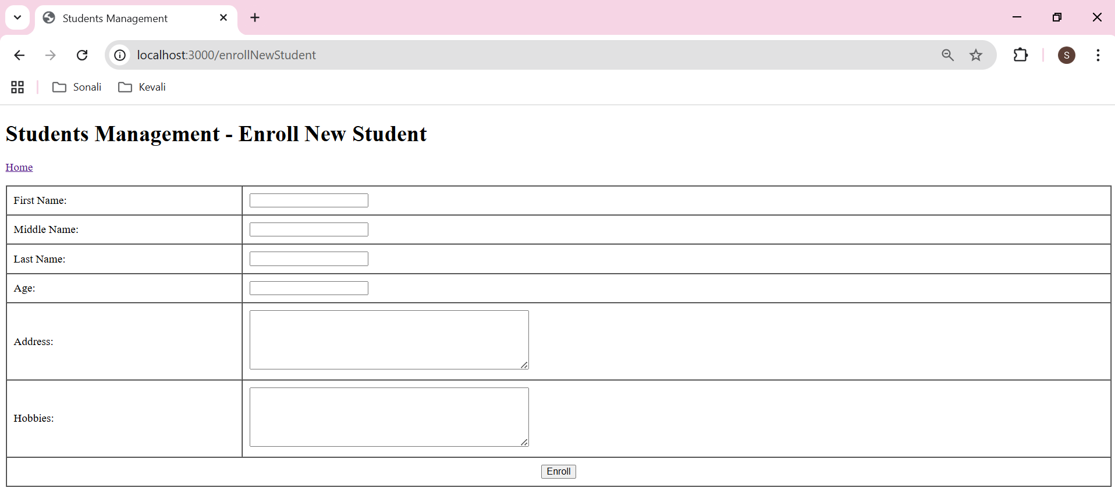

- A POST endpoint ‘/enrollNewStudent’ retrieves the data entered by the user in ‘enrollNewStudent.pug’ template and inserts a new student record in students database table. It provides a link for user to redirect to Home page.
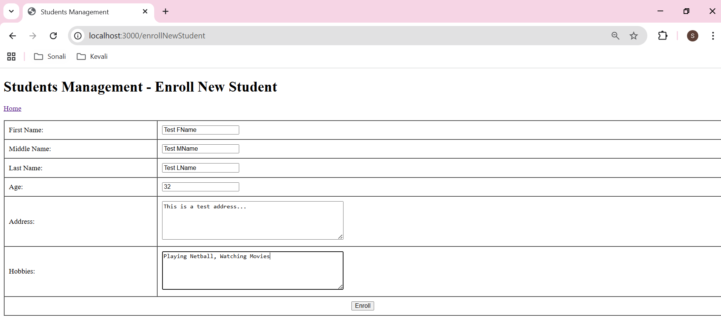

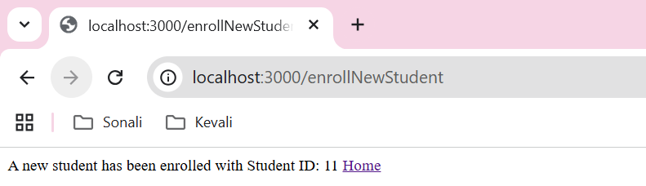

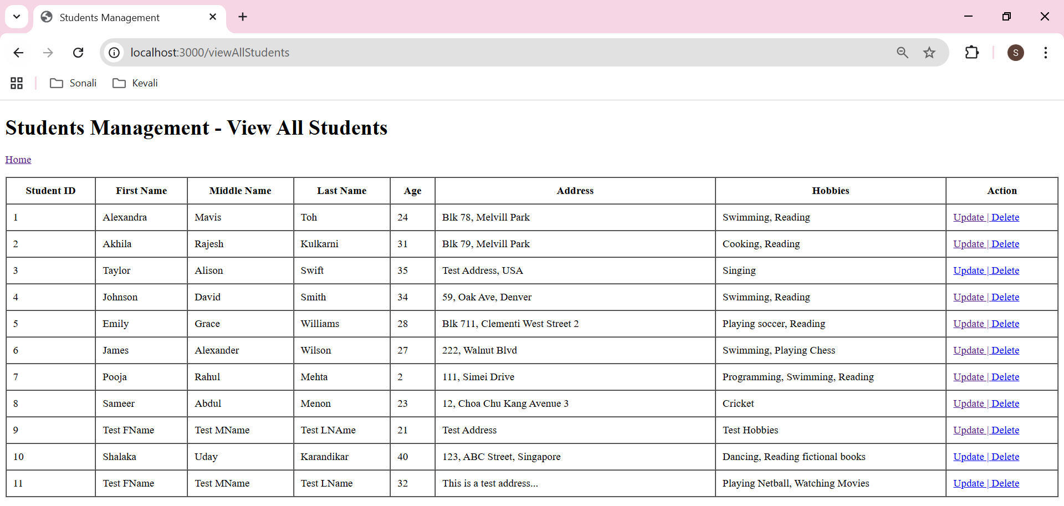

Code from app.js:
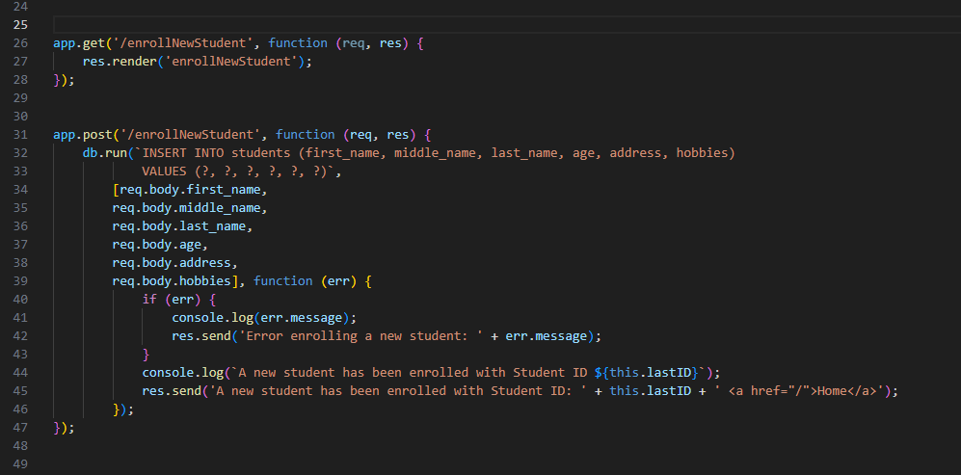

Code from enrollNewStudent.pug:
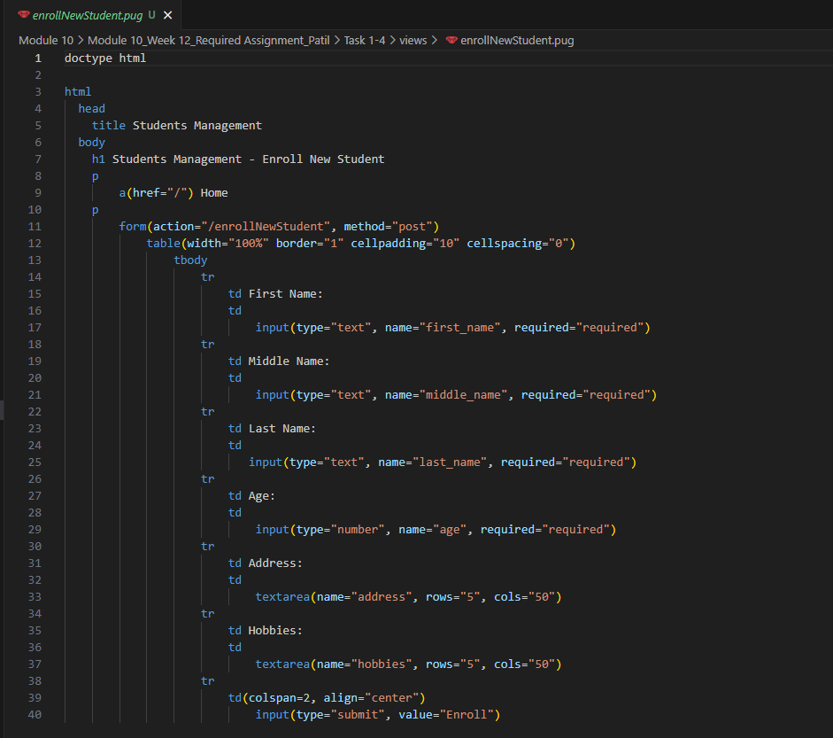

- A GET endpoint ‘/updateStudentInfo’ accepts ‘student_id’ as parameter and retrieves the record for that particular student from the sqlite database. It then displays that record in pug view, ‘enrollNewStudent.pug. User can edit the existing record data here.
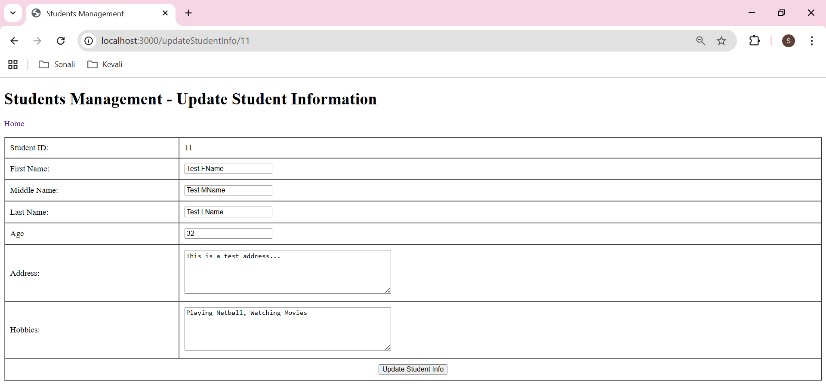

- A POST endpoint ‘/updateStudentInfo’ accepts ‘student_id’ as parameter, retrieves the data edited by user for that particular student id from pug template, ‘enrollNewStudent.pug’. It then updates the student record in sqlite students database. Then it provides a link for user to redirect to Home page.

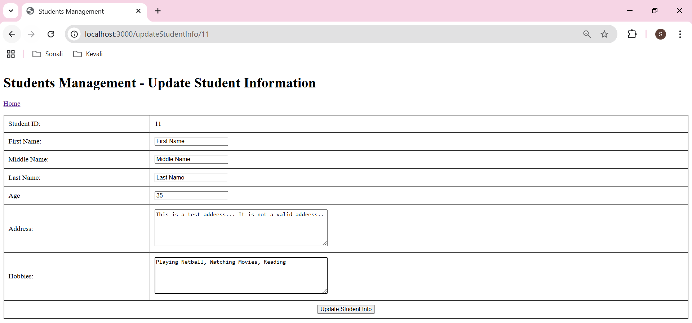

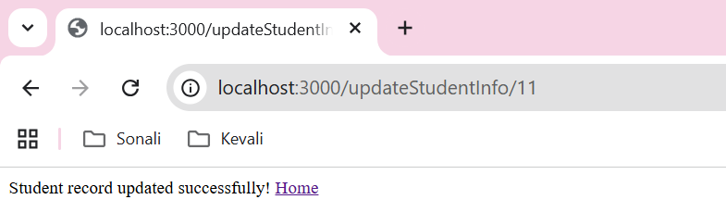

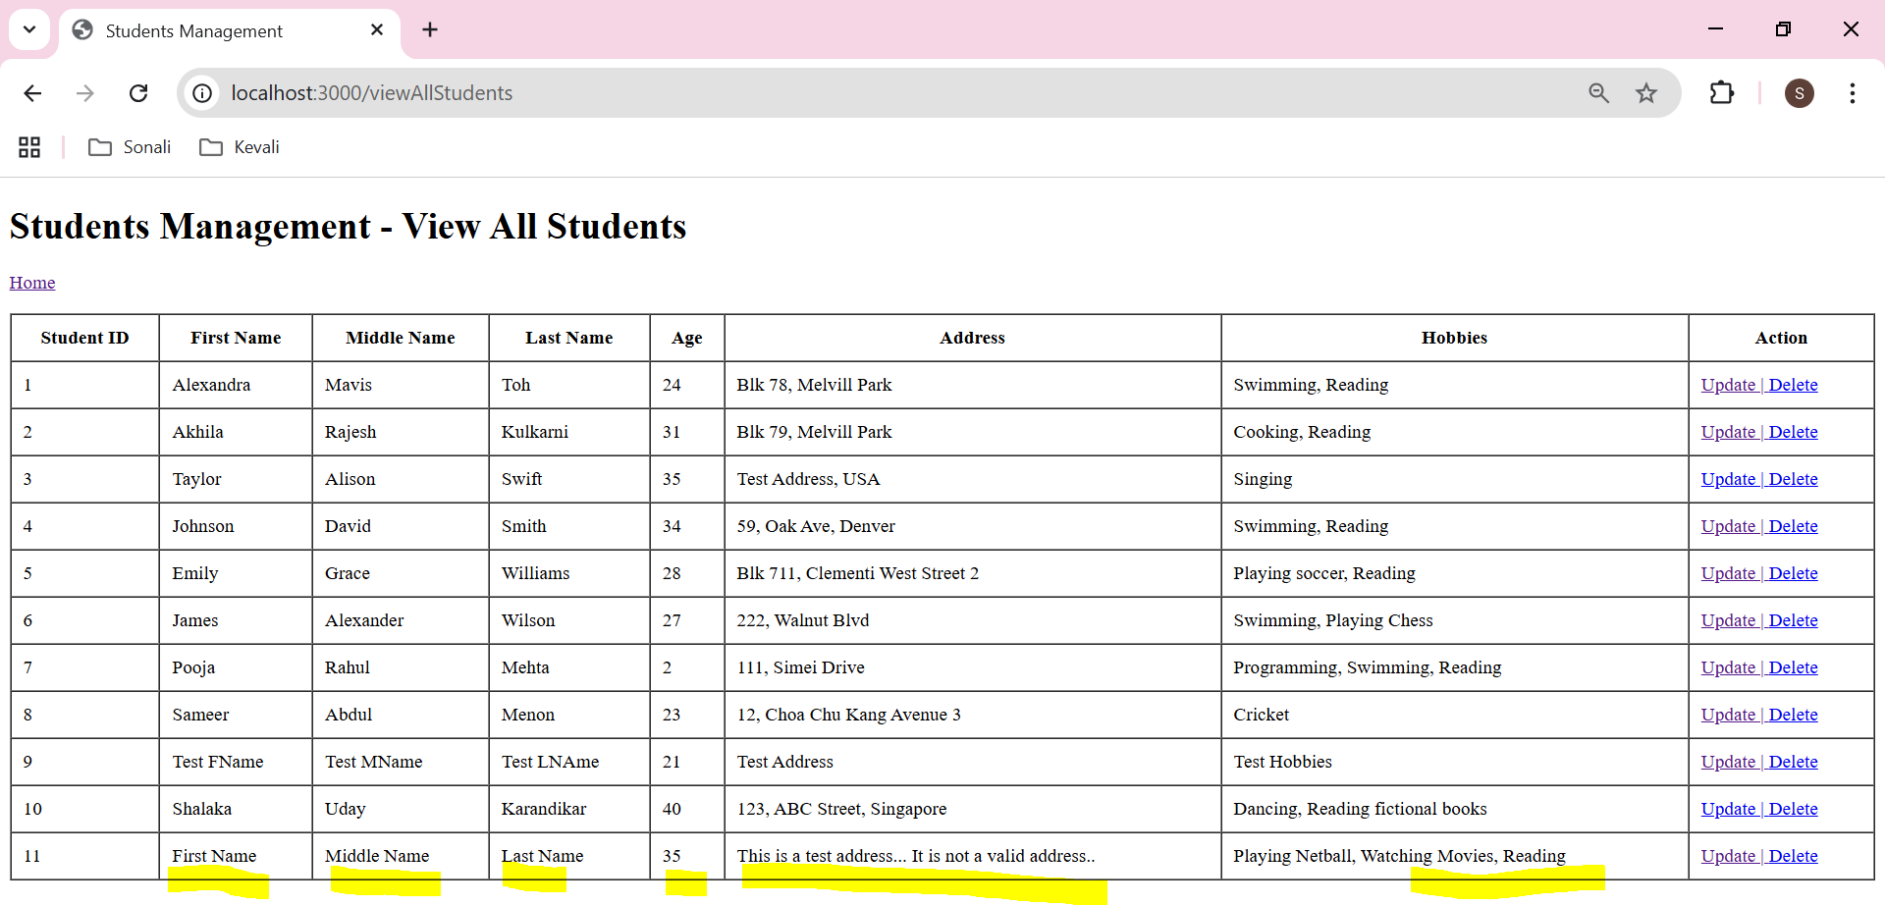

Code from app.js:
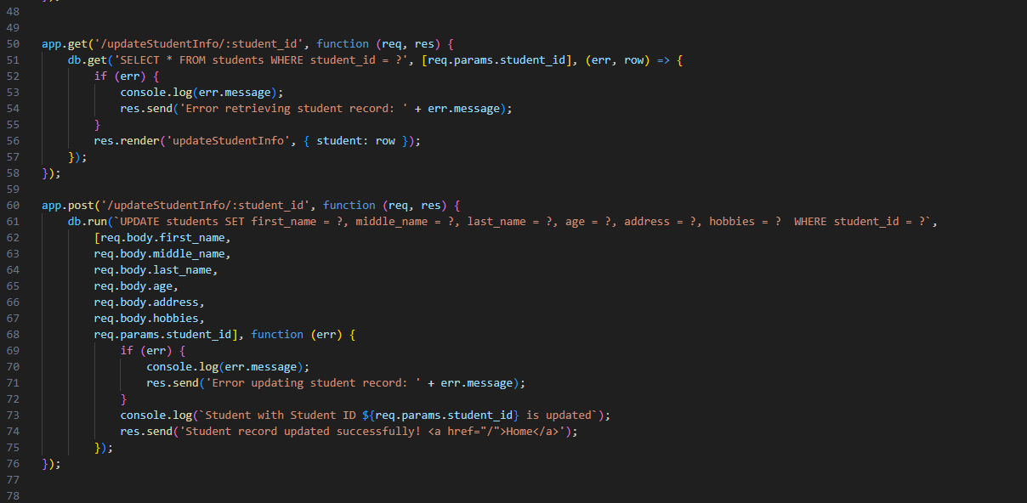

Code from updateStudentInfo.pug:
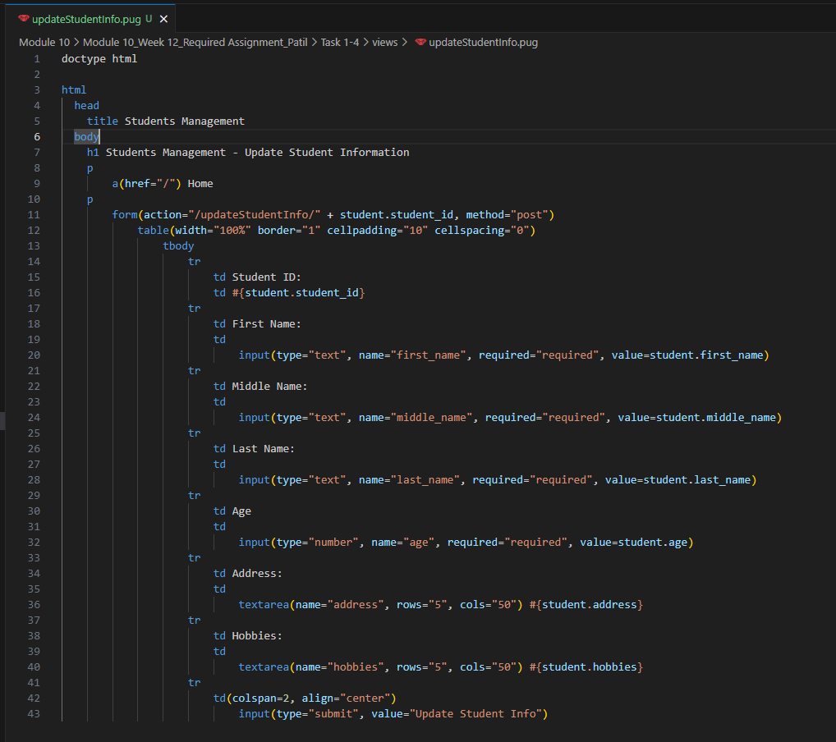

- A GET endpoint ‘/deleteStudentRecord’ accepts ‘student_id’ as parameter, it then retrieves the record for that particular student from ‘students’ database table and displays it using ‘deleteStudentRecord.pug’ pug template.

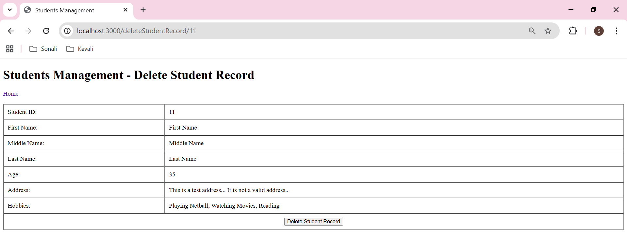

- A POST endpoint ‘/deleteStudentRecord’ accepts ‘student_id’ as parameter, it then Deletes the record for that student by its id. Then it provides a link for user to redirect to Home page.

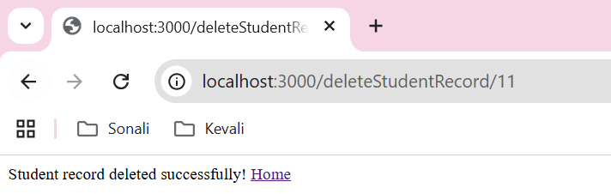

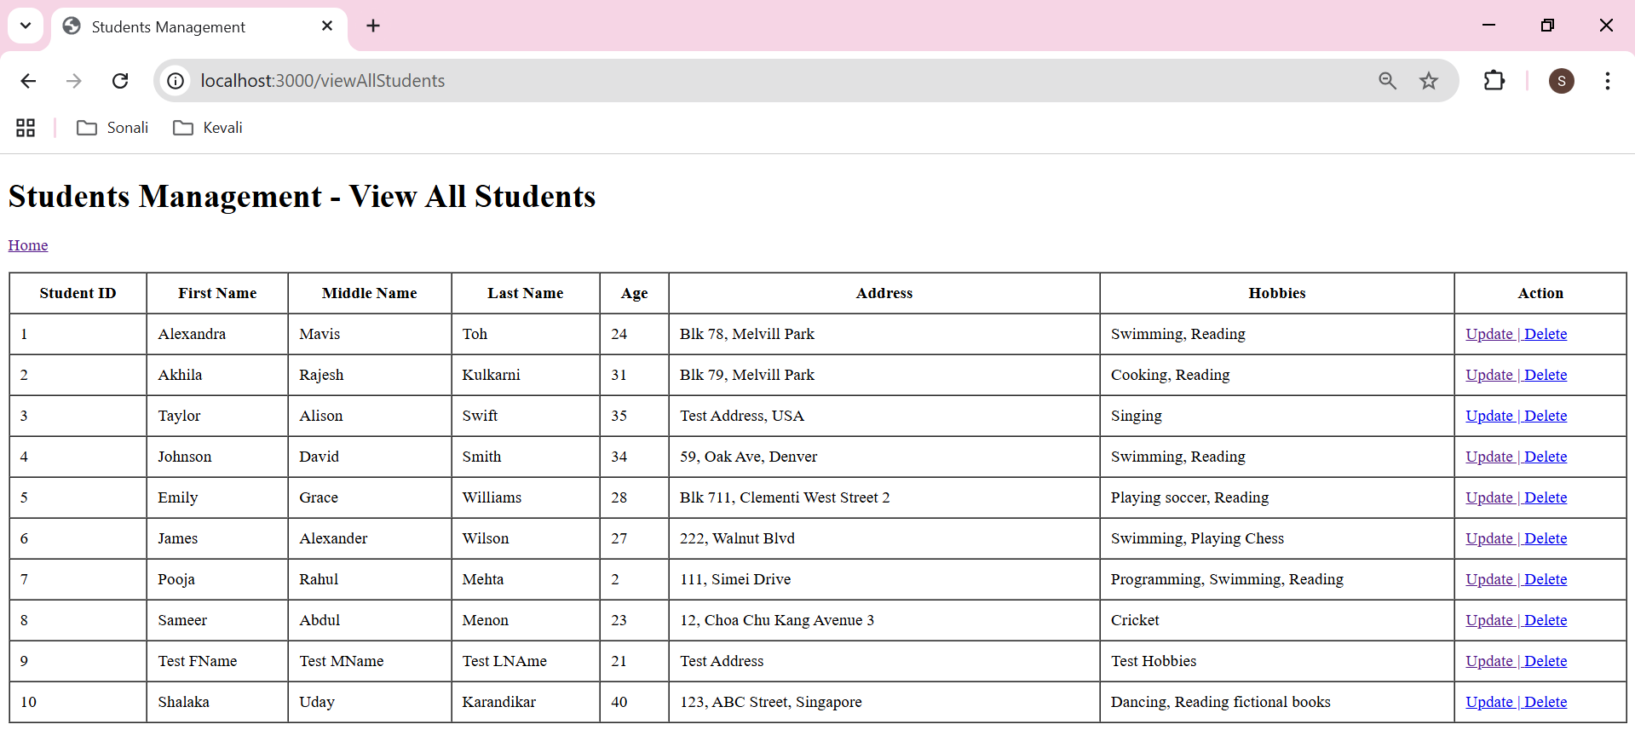
Code from app.js:
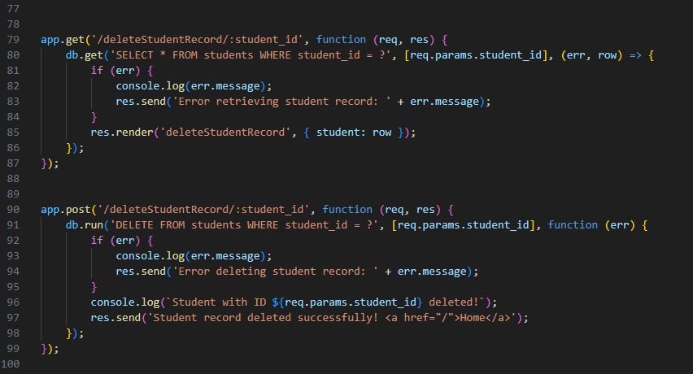
Code from deleteStudentRecord.pug:
